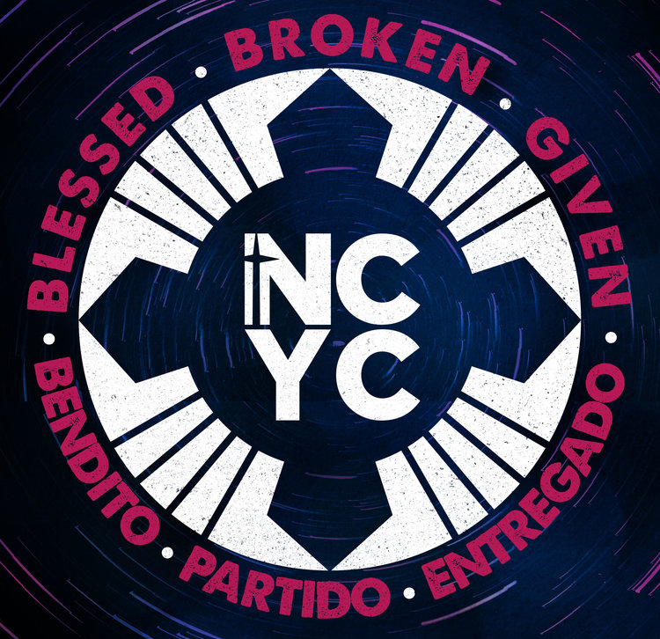

National Catholic Youth Conference
Indianapolis, Indiana
November 21-23, 2019
ATLANTA DELEGATION
PREPARATION PACKAGE 2019

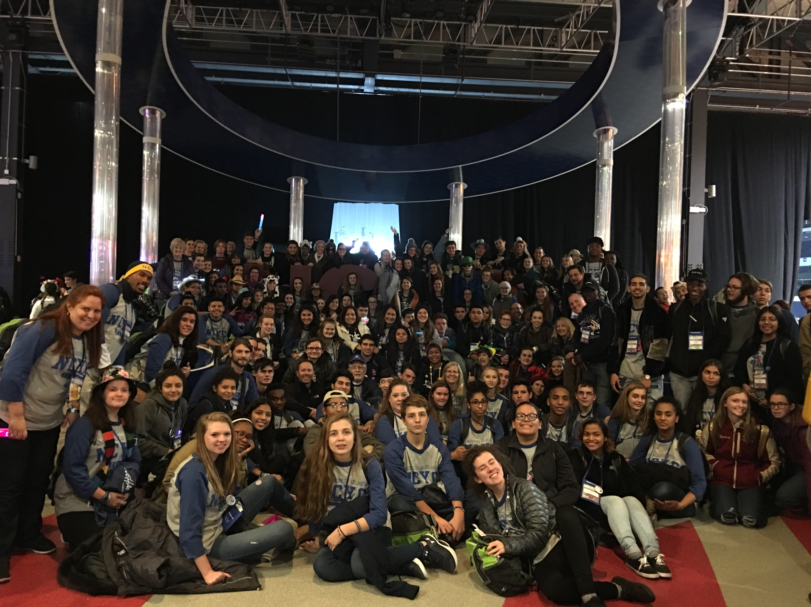

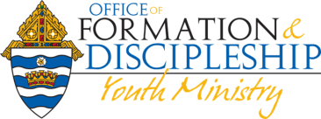

Frequently Asked Questions

What is the National Catholic Youth Conference (NCYC)?
The National Catholic Youth Conference is an exciting, biennial three-day experience of prayer, catechesis, community and discipleship. Teenagers and their adult chaperones learn about the Catholic faith through keynote presentations and workshop sessions that address a wide variety of topics. The Eucharist is celebrated daily and the sacrament of reconciliation is offered in addition to recreation and special activities such as concerts, exhibits, and the interactive thematic park.

Who attends NCYC?
NCYC is open to high school age young people and their adult chaperones. Many youth participants are leaders in their local parishes, schools and/or diocese, though many are just beginning to connect to their faith. Some participants may have experienced a previous NCYC, but many attendees are experiencing this type of gathering for the first time.

Chaperones
NFCYM requires that chaperones be 21 years or older. The diocesan group must have at least two chaperones for first one to ten youth and one additional adult for each additional one to six youth.

Who sponsors NCYC?
The National Federation for Catholic Youth Ministry (NFCYM) sponsors NCYC.

For more information and questions, please contact: Elaine Phillips
Office of Formation & Discipleship
404-920-7633
ephillips@archatl.com

Please return all required forms, applications and payments to:
Elaine Phillips / NCYC 2019
2401 Lake Park Drive, SE
Smyrna, GA 30080

Registration Cost
All participants from the Archdiocese of Atlanta must register through the Office of Formation & Discipleship.

Parishes must identify and provide their own transportation. Parishes are encouraged to collaborate and communicate based on their preferred transportation services. Transportation is not provided by the Archdiocese.

- NCYC registration fee $ 225.00 per person
- 3 nights hotel stay based on quad occupancy $ 165.00 per person

If adults want to have double occupancy $ 330.00 per person*
(*Depending on availability- ONLY FOR ADULTS)

- 3 Archdiocese of Atlanta long sleeve t-shirts $35.00 per person
- One Hat and one backpack $25.00 per person

Total cost per person: $450.00
$ 615.00 (* adult on double occupancy)

NFCYM Late Fees apply after September 30, 2019

Initial Parish Registration by the Youth Minister - Due: June 14, 2019
An email from the youth minister, with the number of adults (21+ old), and number of high school age teens is required. After June 14th you may ADD teens based on availability, but if you drop any spots you’ll STILL BE RESPONSIBLE for the full cost of that spot.

Payment Schedule
1st payment (Deposit) due by June 14, 2019
$100.00 per person

2nd payment due by September 6, 2019
$175.00 per person

Final Payment due by OCTOBER 1, 2019
$175.00 per person

PLEASE NOTE that payments are non-refundable as the Archdiocese is required to make pre-payments to the hotel and for the registration fee. However, substitutions can be made up until October 30th for a $20.00 fee per substitution.

Unreserved hotel rooms will be released back to NFCYM on August 14, 2019.
Please make checks payable to the Archdiocese of Atlanta

Hotel
Sheraton Indianapolis City Centre Hotel
31 W. Ohio St., Indianapolis, IN, 46204
317-635-2000
Website: http://www.sheratonindianapoliscitycentre.com/

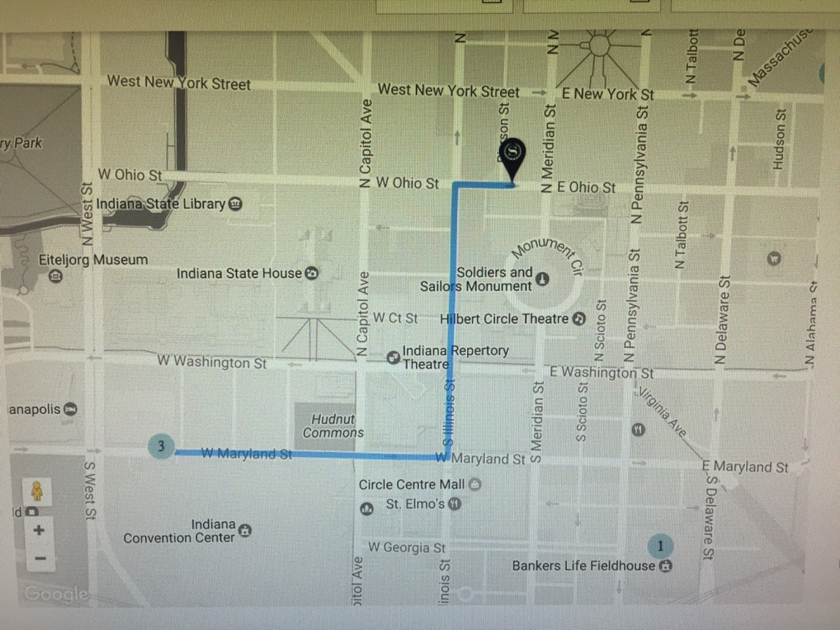

NCYC 2019:
MC’s
Kate Prejean McGrady Fr. Agustino Torres, CFR

KEYNOTE SPEAKERS
Immaculée Ilibagiza Mark Hart Sr. Bethany Madonna SV
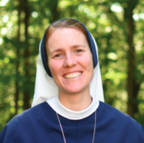

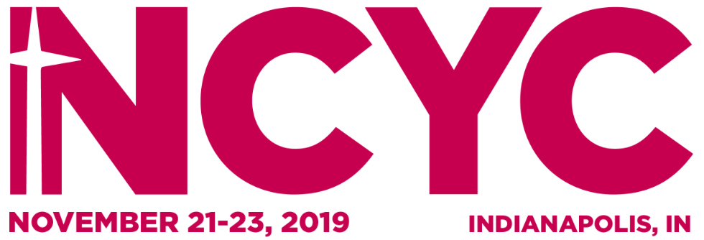
CLICK TO VIEW A PROMOTIONAL VIDEO

